PG-DBDA (March 2024cBatch set-B)

Name : Omkar Ankush Bhosle

LINUX

Q1. Write shell script to check if given year is leap year

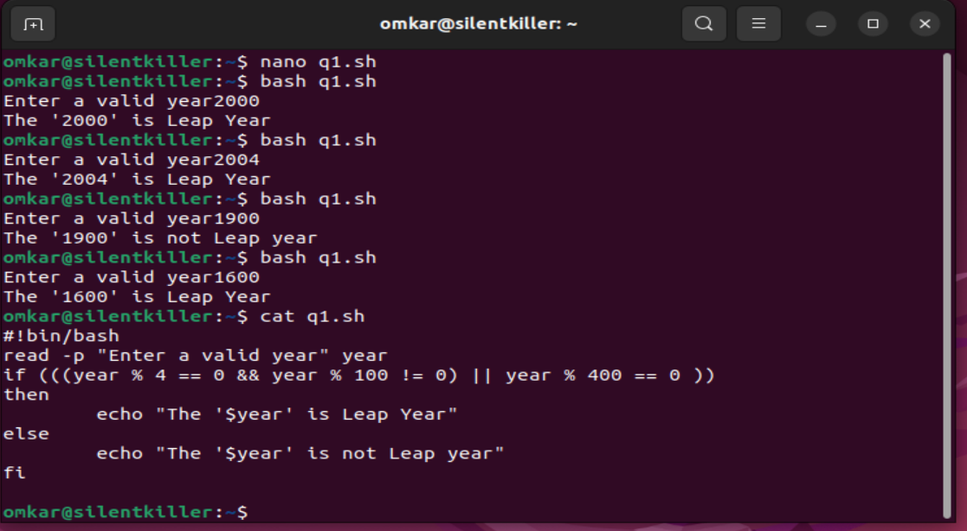

Q2. Write shell script to print the fibonacci series up to certain number entered by user

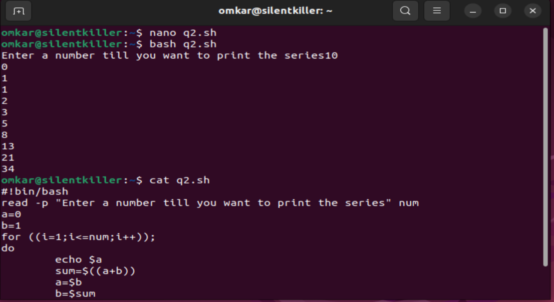

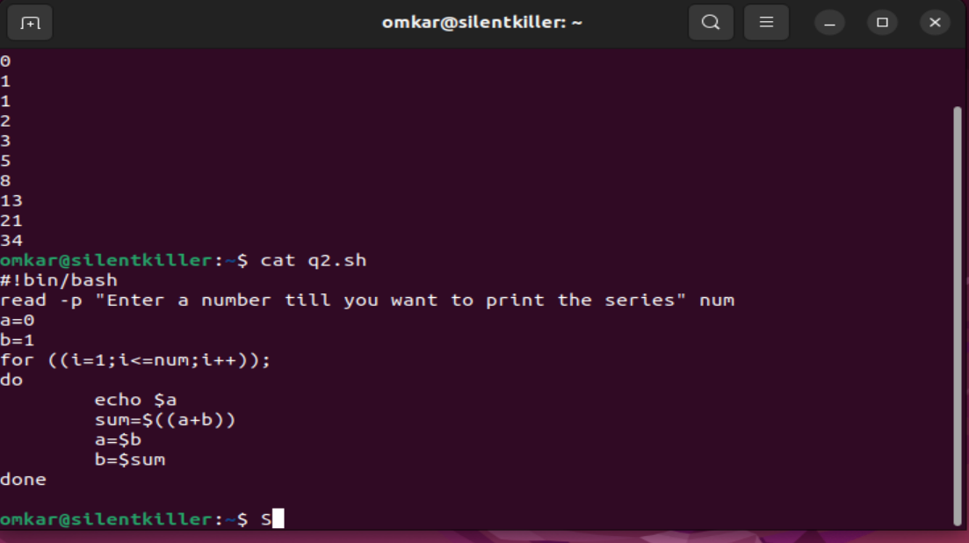

Q3. write linux directory and file management script that allows user to perform following actions

Making new directory

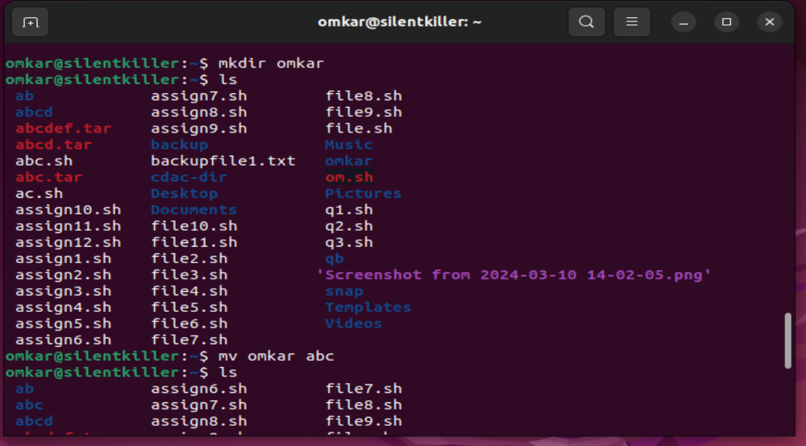

Rename existing directory

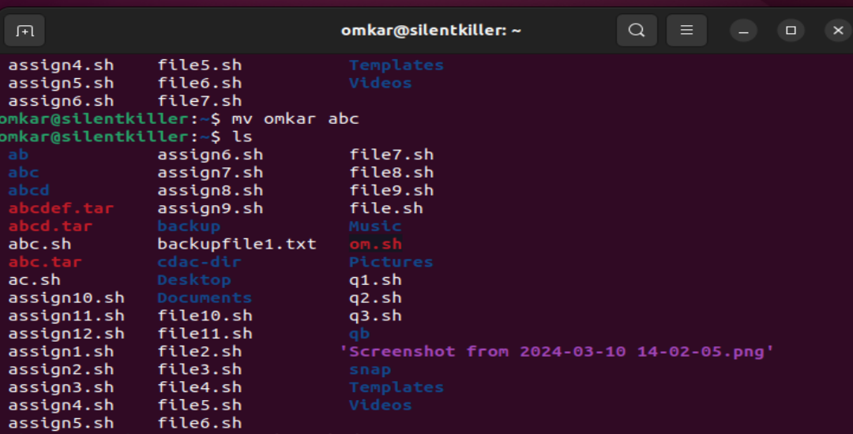

Move an existing directory

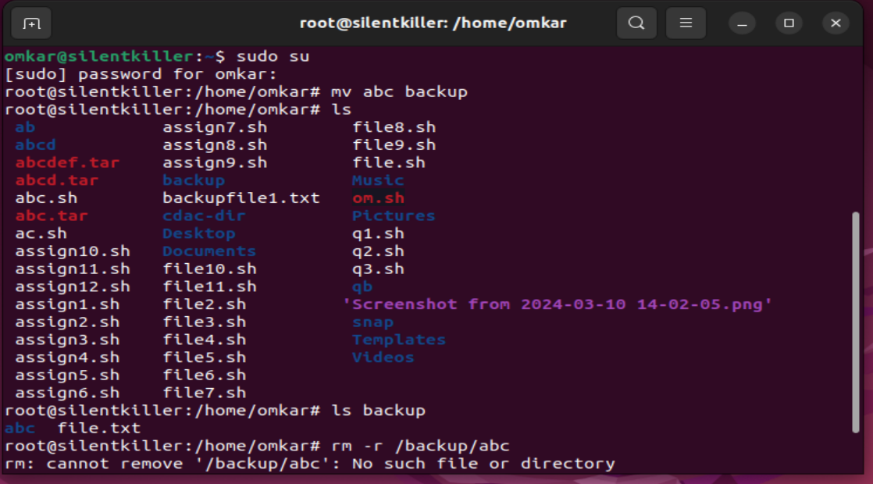

Delete directory

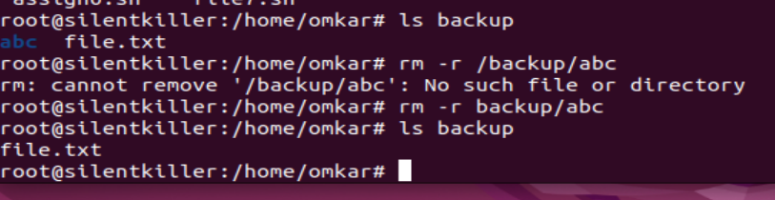

Create file and create hardlink

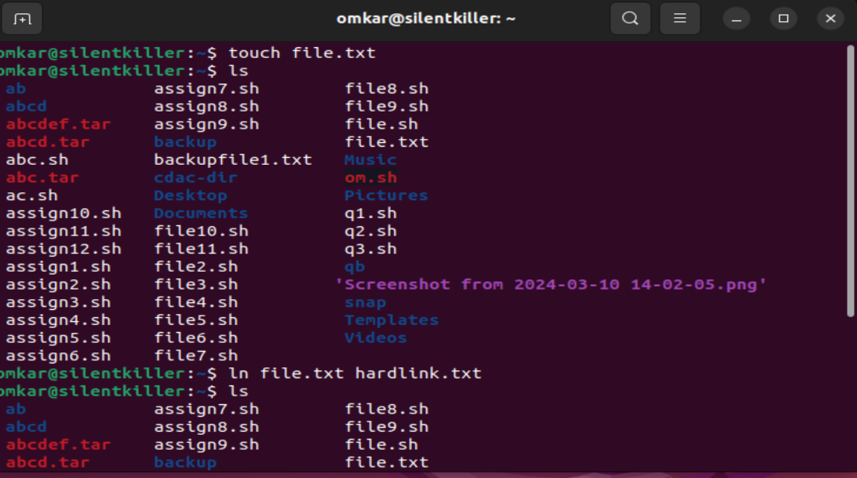

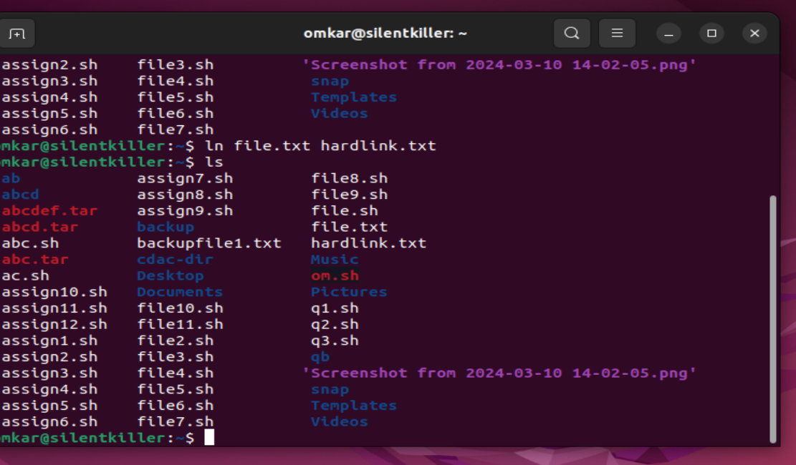

CLOUD

Q1. EC2

Creating Ec2 instance

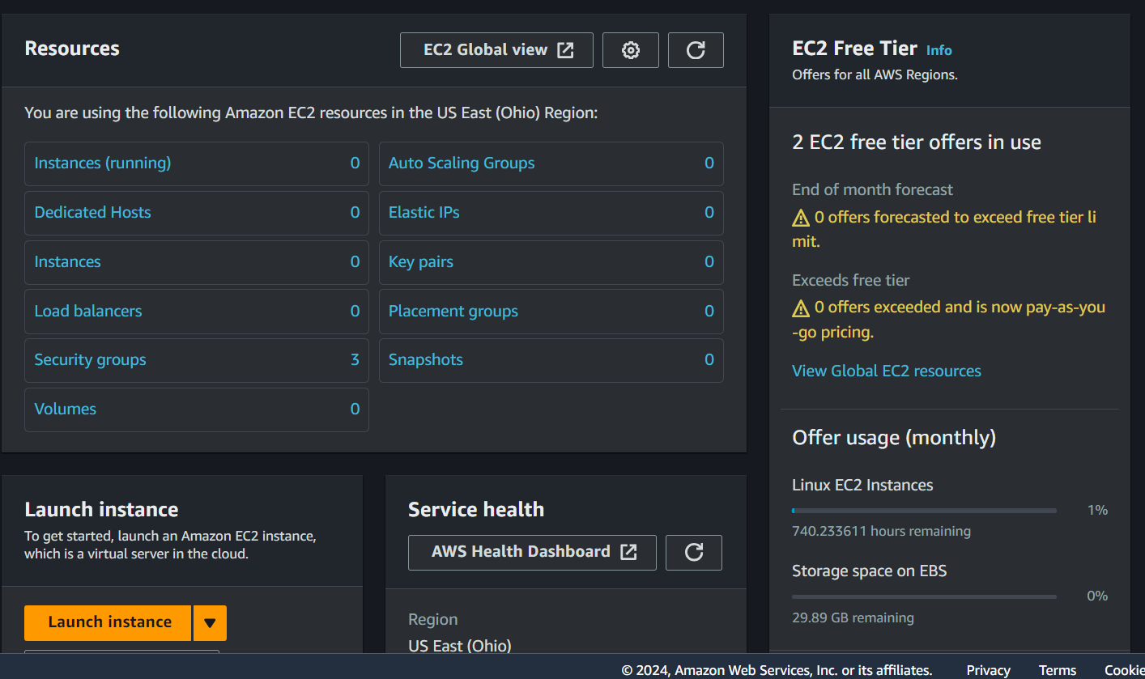

Giving name:

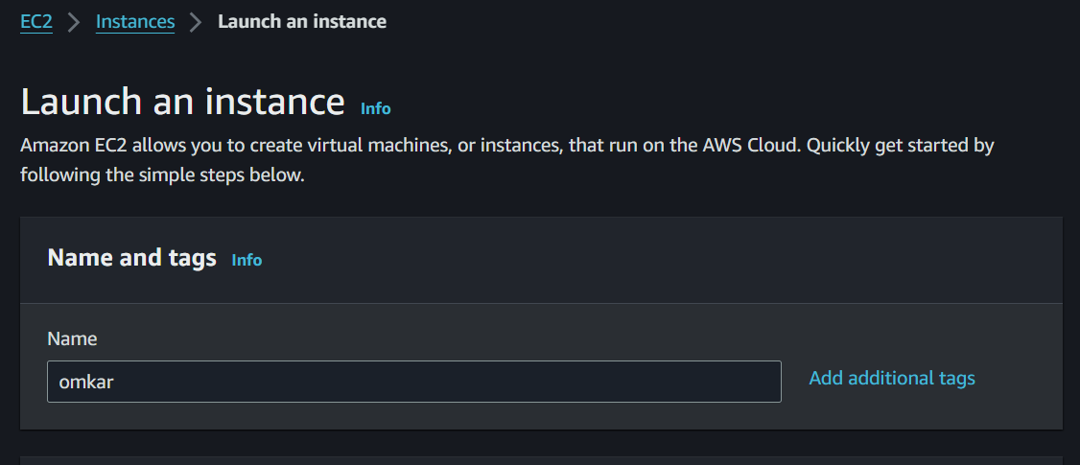

Choosing Linux AMI:

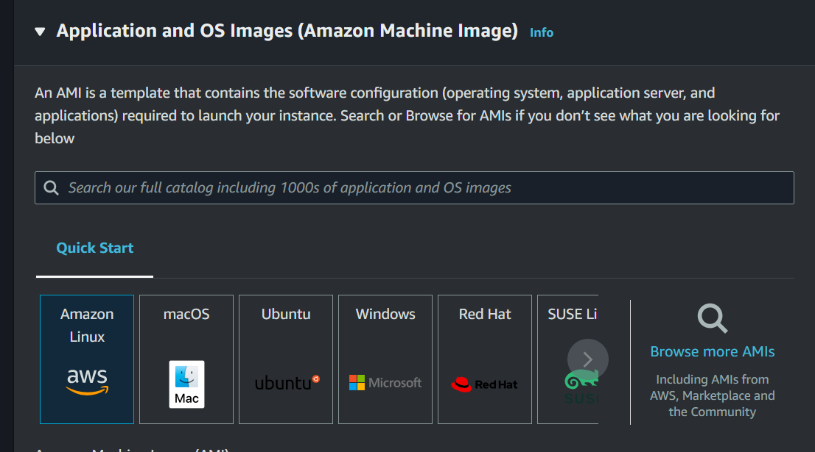

Choosing t2.micro instance type:

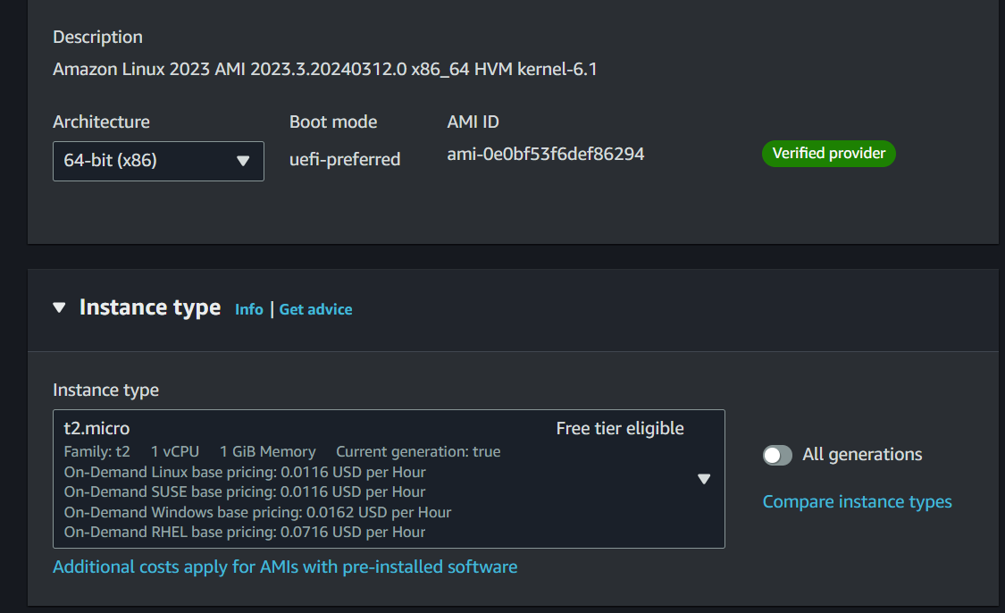

Creating new key pair:

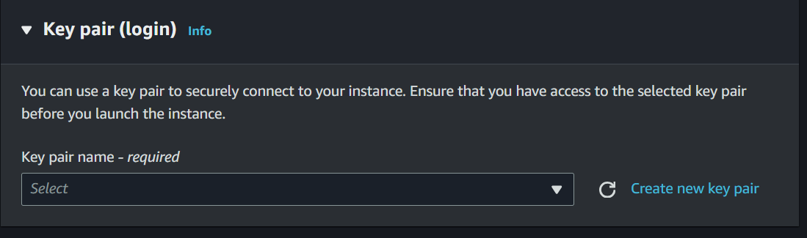

Giving key pair name omkara and type RSA and format .ppk

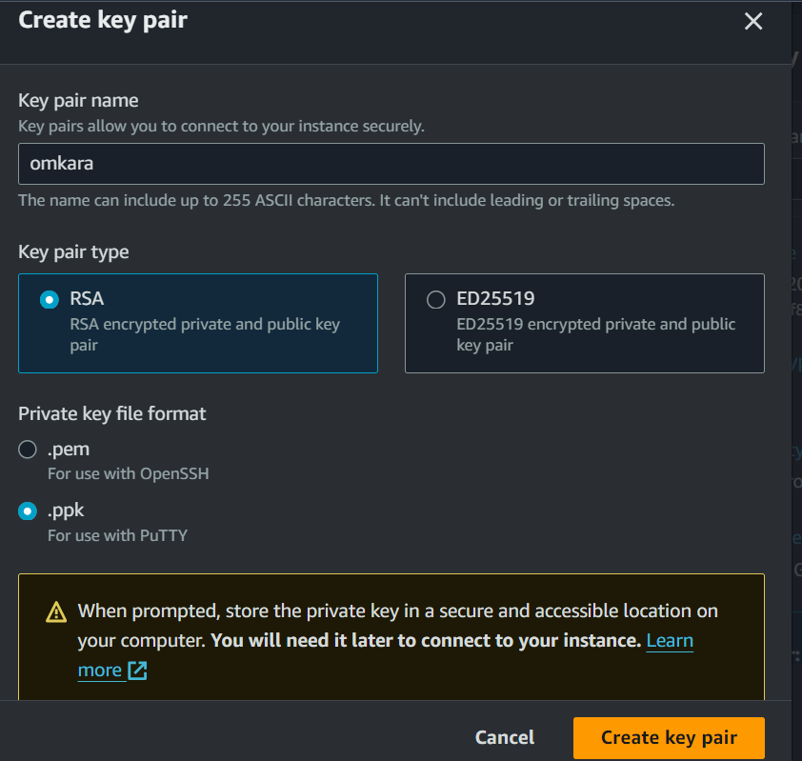

Key pair created :

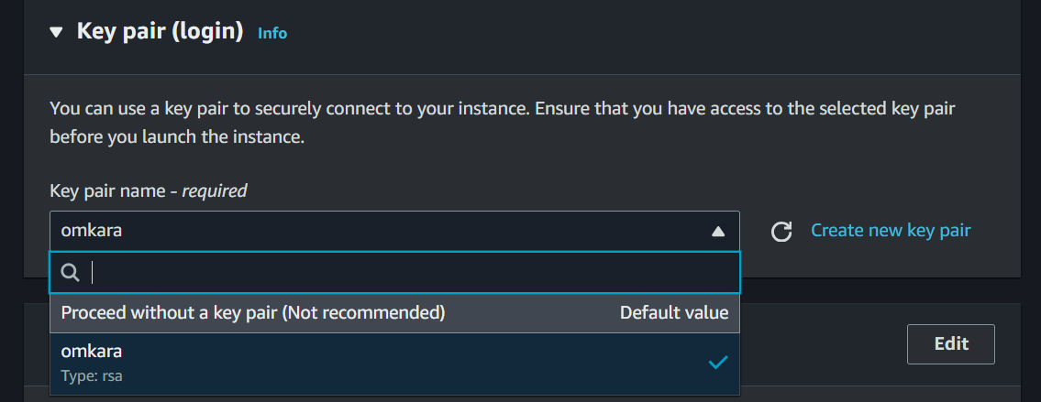

Keeping network setting as it is:

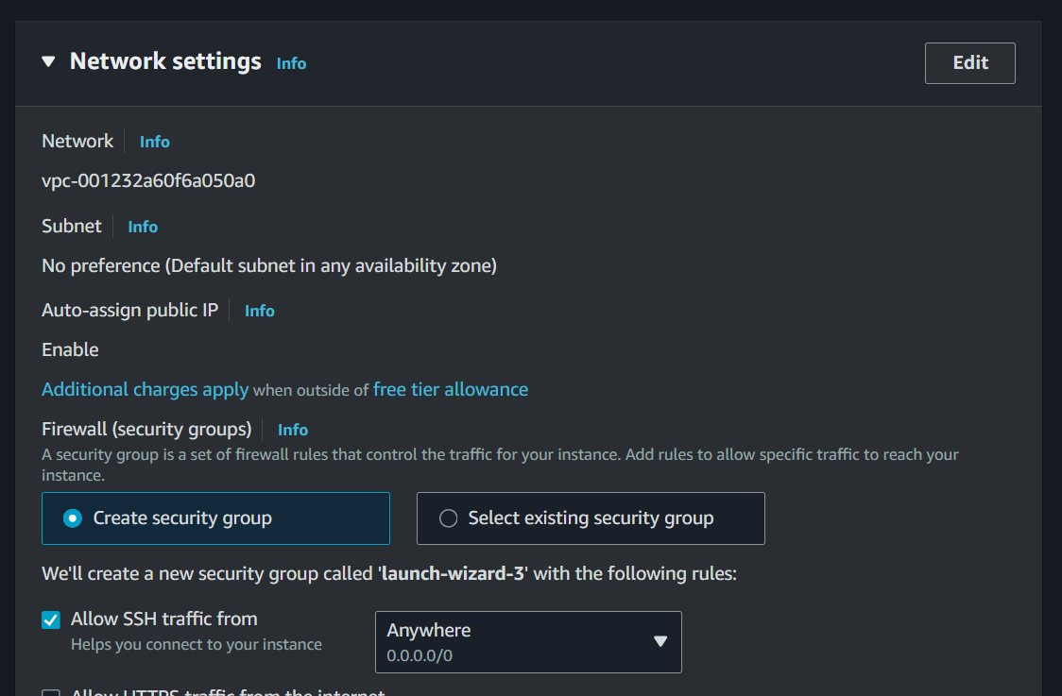

Tick Allow http:

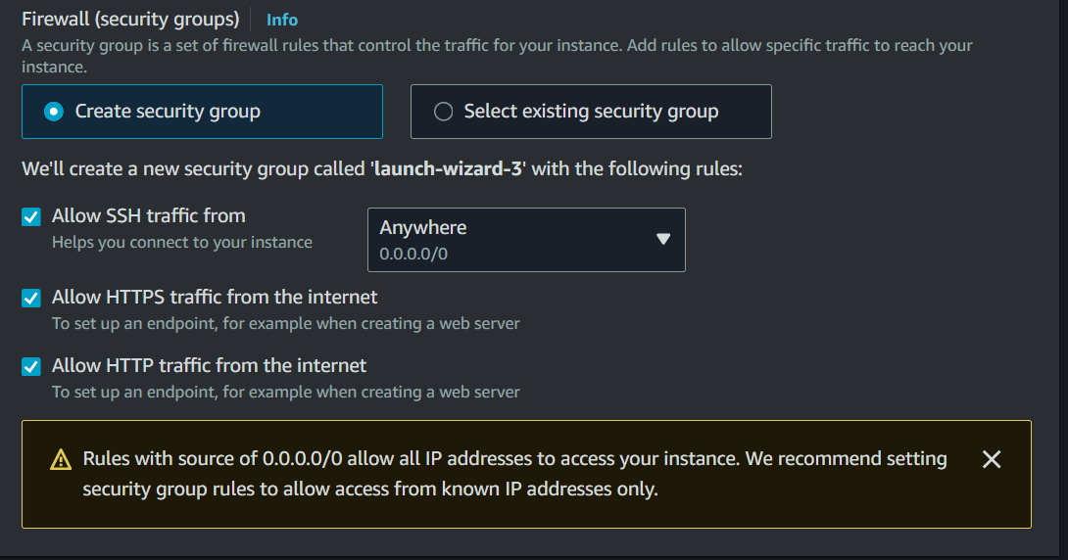

Configure storage keeping as it is:

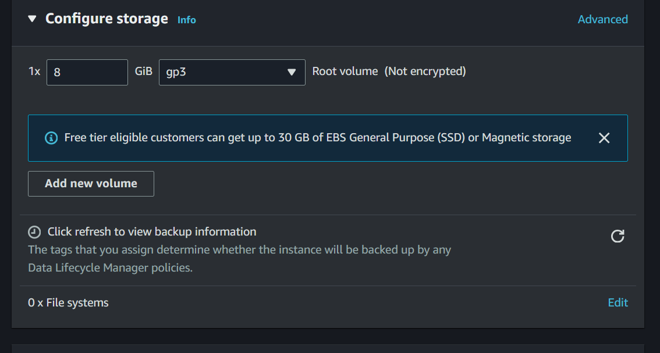

Launching instance:

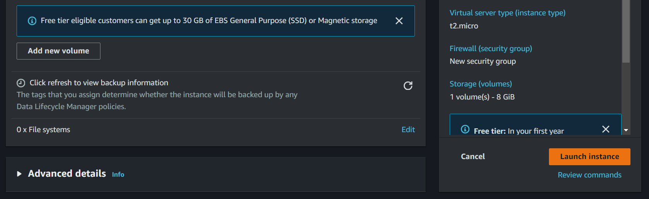

Instance launch :

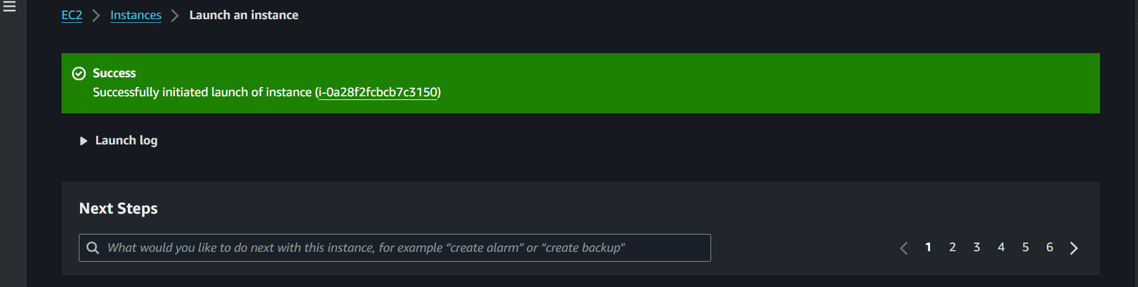

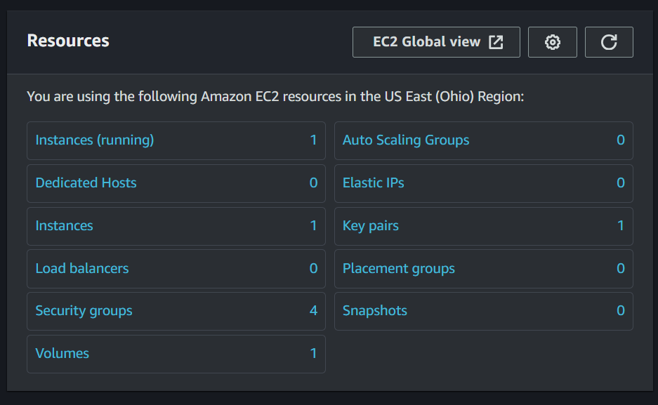

Instance summary and selecting ip address :

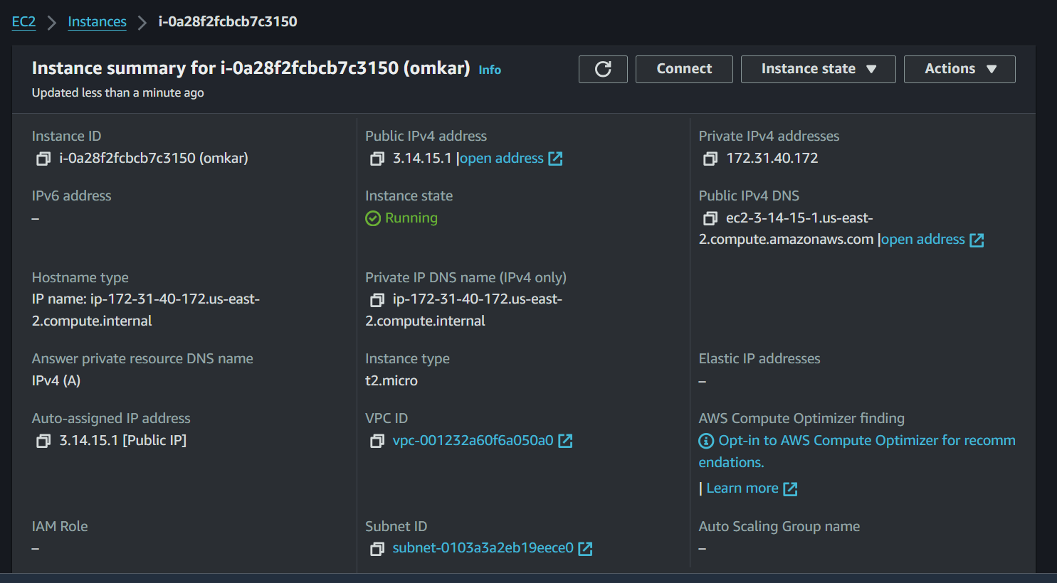

Selecting ip address Public IPv4:



Open putty:

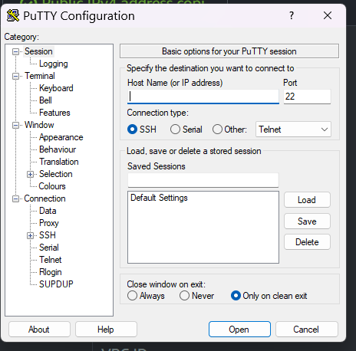

copying public ipv4 and paste it in host name :

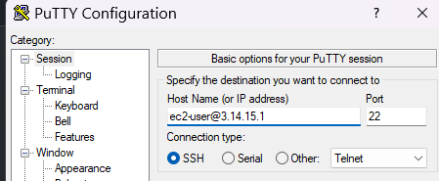

Going in SSH then Auth then selecting Credential:

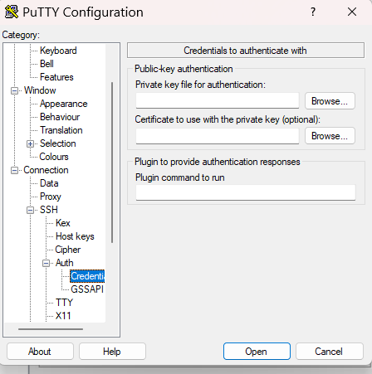

Browse private key omkara and then click on open

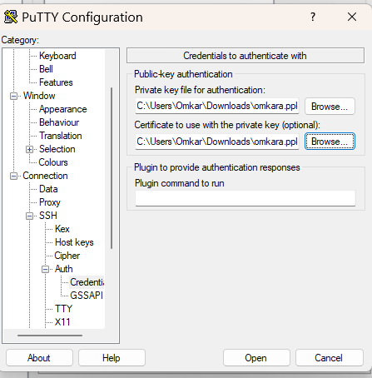

After opening then click on accept :

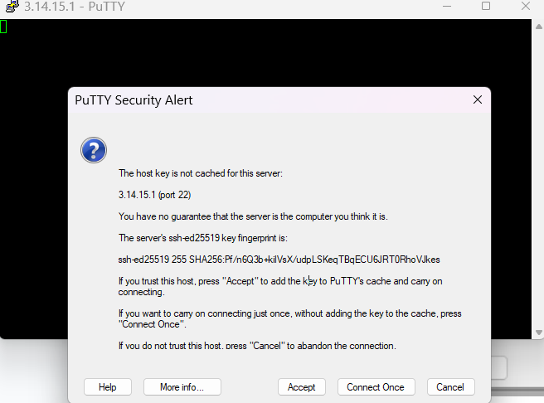

Putty opened:

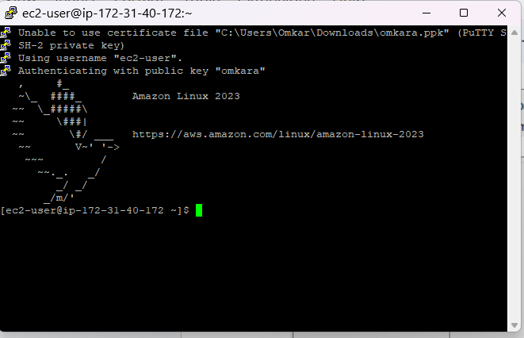

Sudo -i : to enter in root:

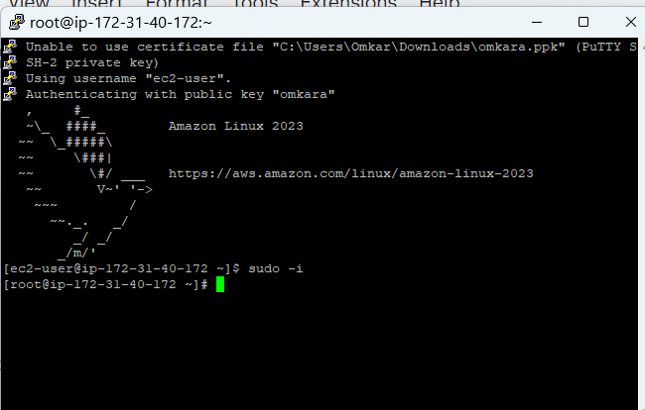

Yum update -y: to update system

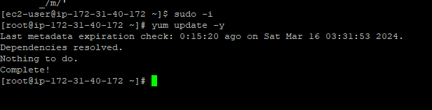

Yum install httpd -y: to install httpd

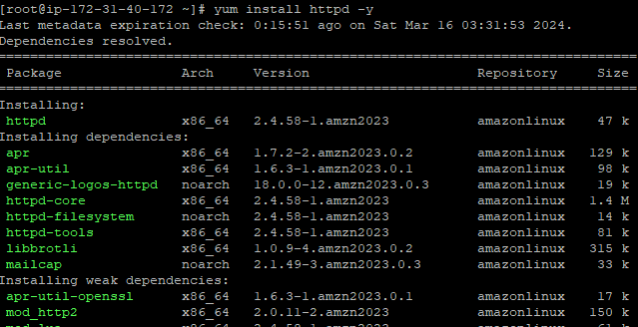

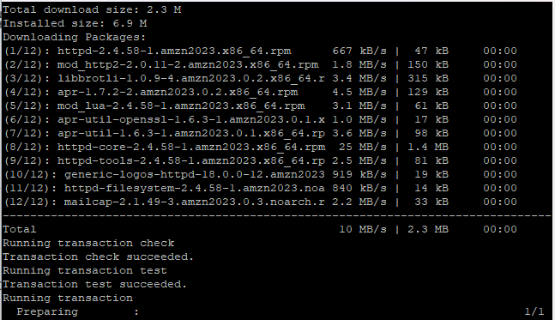

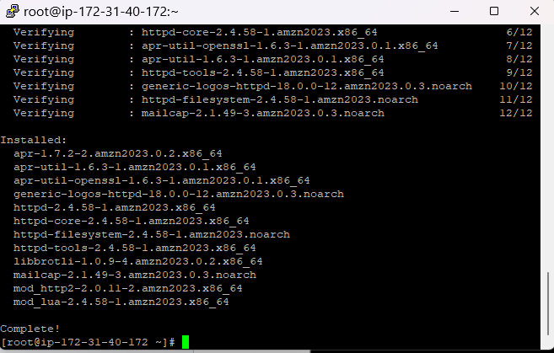

Systemctl start httpd: to start httpd

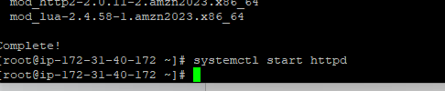

Systemctl status httpd: to check status of httpd

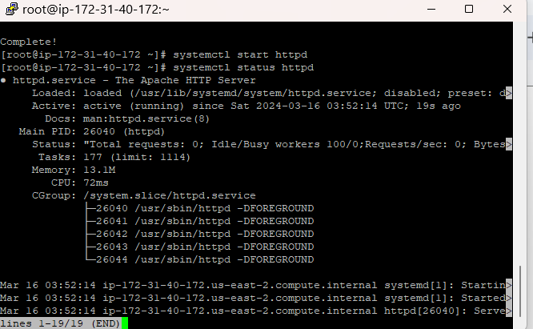

Systemctl enable httpd: to enable httpd

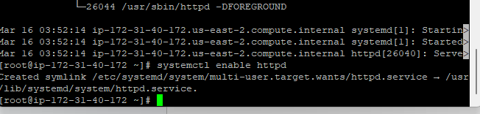

To change directory into html:



Create new file index.html:



Basic html code to display my name:

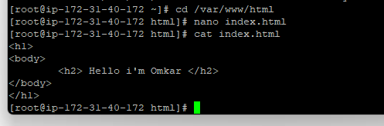

Html page successfully created:

